“Software Requirements Specification (SRS)

for Alumni Meet App and Job Reference Web Application”

# Introduction

The Alumni Meet App and Job Reference Web Application is a comprehensive platform designed to facilitate professional networking, career advancement, and job opportunities for college alumni. It aims to connect alumni with their alma mater, fellow graduates, and potential employers, providing a centralized hub for various activities and services.

# Purpose

The primary purpose of this application is to:

* + 1. To facilitate the adoption process for children, pets, and parents.
    2. To raise awareness about the importance of adoption and its impact on individuals and families.
    3. To provide ongoing support and resources for adopted children, pets, and parents.

# Intended Audience

The intended audience for this application includes:

* Prospective adoptive parents interested in adopting children, pets, or both.
* Individuals and families considering adoption as a way to expand their family.
* Community organizations and stakeholders invested in supporting adoption initiatives.

# Project Scope

The scope of this project includes the following key features:

* User registration and authentication for alumni, faculty, staff, and employers.
* Alumni profile creation and management.
* Event creation, management, and registration for alumni meet-ups.
* Job posting and application management.
* Reference request and management system for alumni.
* Search functionality for events, job postings, and user profiles.
* Content sharing and interaction (posts, updates, etc.) among alumni.

# Overall Description

The Alumni Meet App and Job Reference Web Application will provide a comprehensive platform for alumni to connect, collaborate, and advance their careers. It will offer a user-friendly interface and a robust set of features to cater to the needs of alumni, faculty, staff, and potential employers.

# Benefits

The key benefits of this application include:

* Strengthened alumni community and increased networking opportunities.
* Streamlined job search and application process for alumni.
* Efficient reference management system for job applications.
* Improved collaboration and knowledge sharing among alumni.
* Enhanced visibility for alumni and their career achievements.
* Centralized platform for alumni events and job postings.

# Future Scope

The application can be further enhanced with additional features and functionalities, such as:

* Integration with social media platforms for broader outreach.
* Virtual event hosting and participation.
* Mentorship programs and career guidance services.
* Alumni directory and advanced search capabilities.
* Alumni-exclusive discounts and offers.
* Alumni donation and fundraising initiatives.

# Components

The application will consist of the following main components:

# User Management

This component will handle user registration, authentication, and profile management for alumni, faculty, staff, and employers. Users can create and update their profiles, including details such as work experience, education, skills, and achievements.

# Alumni Networking

This component will facilitate networking among alumni through connection requests, messaging, and content sharing. Alumni can connect with fellow graduates, faculty members, and potential employers, enabling professional collaboration and knowledge exchange.

# Event Management

This component will allow administrators to create and manage alumni meet events. Alumni can browse and register for upcoming events, fostering a strong alumni community and facilitating in-person networking opportunities.

# Job Posting and Application

This component will enable employers and administrators to post job opportunities. Alumni can search for relevant job postings, view details, and apply directly through the application. Additionally, alumni can manage their job applications and track their status.

# Reference Management

This component will allow alumni to request references from faculty members, staff, or other alumni for job applications. Reference providers can manage and respond to reference requests, providing valuable recommendations and endorsements.

# Search and Filtering

This component will provide advanced search and filtering capabilities for events, job postings, and user profiles. Users can search based on various criteria, such as location, industry, job title, or alumni affiliation, to find relevant information and connections.

# Requirements for this project:

* 1. **Functional Requirements**
     + User registration and login functionality.
     + Event creation and management functionality for administrators.
     + Job posting and management functionality for administrators.
     + Application submission and management functionality for users.
     + Reference request and management functionality for users.
     + Search functionality for events, job postings, and users.
  2. **Non-Functional Requirements**
     + **Security**: The application should ensure secure data storage and transmission.
     + **Performance**: The application should respond quickly to user requests.
     + **Usability**: The application should be easy to use and navigate.
     + **Scalability**: The application should be able to handle a large number of users and requests.

# Technical Requirements

* + - **Frontend**: The application will use HTML, CSS, and JavaScript for the user interface.
    - **Backend**: The application will use a web framework such as Node.js or Django for the server-side logic.
    - **Database**: The application will use a relational database management system such as MySQL or PostgreSQL for data storage.

# Basic Relationship Diagram

Here's a basic relationship diagram depicting the key entities and their relationships in the Alumni Meet App and Job Reference Web Application:

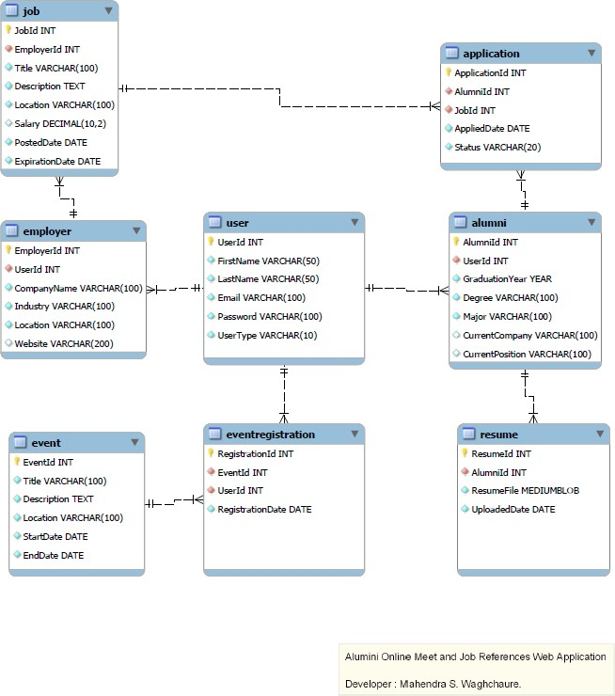

This diagram illustrates the relationships between the key entities, including User, Alumni, Faculty, Event, Event Registration, Reference, Job, and Application. It provides a high-level overview of how these entities interact and connect with each other within the application.

# Conclusion

The Alumni Meet App and Job Reference Web Application is a comprehensive platform designed to foster a strong alumni community, facilitate professional networking, and provide a job reference system.

By offering a user-friendly interface and a robust set of features, this application will cater to the needs of alumni, faculty, staff, and potential employers, enabling seamless collaboration, career advancement, and knowledge sharing.